Objective

Install a capability that extend the application (Innovasy Help Studio), in which the online help always highlights the current topic in the Table Of Contents (TOC)

Scope

The plug-in is implemented and tested for HelpStudio 3.5.0.22 and HelpStudio 3.5.0.34.

References

HELP: (Innovasy Help Studio System):
http://www.innovasys.com/

DEV.REP.01.TOC Highlight plug-in

Definitions

TOC: (Table Of Content).
It is the list that describes the way the Help System’s topics are ordered and organized.

Plug-in:
Is a computer program that interacts with a host application (a web browser or an email client, for example) to provide a certain, usually very specific, function "on demand".

Online Help:
User assistance provided in a program or application that is typically accessed in a separate section of that application.

Topic.
One Information Unit ( of The BCH Central Portal) that maybe a combination of text and graphics, clearly identified inside a BCH Project TRAINING Module, by its Module Number, Chapter, Section and Paragraph.

Content

Installation procedure for TOC Highlight plug-in

Shut down Help Studio.

Point your file browser to the folder where HelpStudio stores the files for the template, which typically is Documents and Settings\All Users\Application Data\innovasys\documentx5\templates\helpstudio_2005. We will call this folder the template folder.

Make a backup copy of files webtoc.html and Standard.html. This will allow to later un-install the plug-in if necessary.

Copy webtoc.html and Standard.html from the plug-in Deploy folder to the template folder. Make sure you copy the files corresponding to your version of HelpStudio. To check the version of HelpStudio, open HelpStudio, click Help, About, the close HelpStudio again.

Copy the file TOCHighlight.js from the Deploy\script folder into the script folder which is inside the template folder.

Un-installation procedure for TOC Highlight plug-in

Shut down HelpStudio.

Point your file browser to the folder where HelpStudio stores the files for the template, which typically is Documents and Settings\All Users\Application Data\innovasys\documentx5\templates\helpstudio_2005Error: Reference source not found. We will call this folder the template folder.

Copy the files backed up during installation (webtoc.html and Standard.html) back into the template folder.

Delete the file TOCHighlight.is from the script folder which is inside the template folder.

AnneX

Example without plug-in

Depicts this situation: the user has fallen into the “What is the Cartagena Protocol on Biosafety“ unit of information, but cannot see where in the tree structure it is contained.
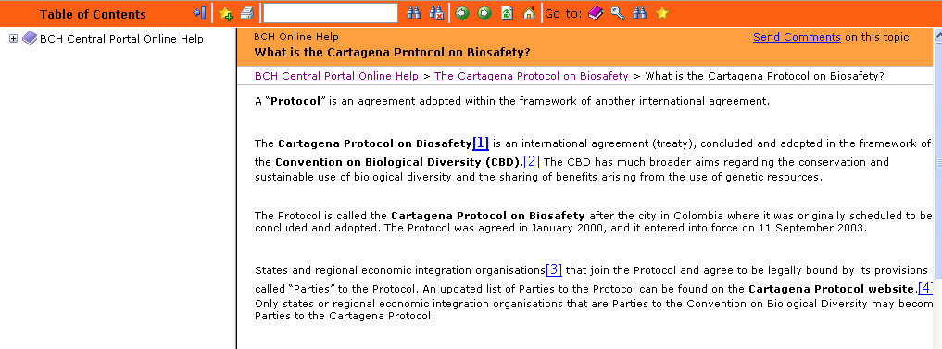

6.2 Example with plug-in installed.

Shows the results of entering to the same unit of information from an external link, in a system using the plug-in.

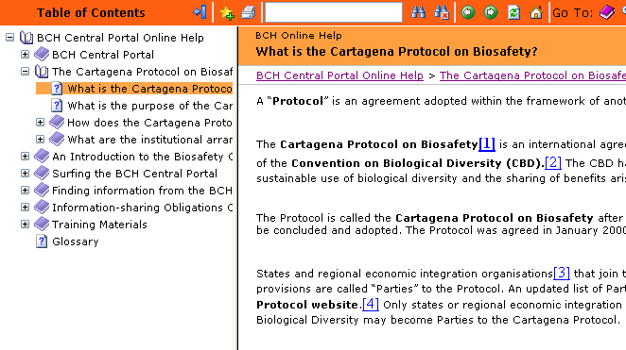

The path to this folder may differ if HelpStudio was not installed for all users, of if the template being used is other than “helpstudio2005”.

